
G U I D A N C E

Managing Traffic Safety on School Premises

Traffic Management Plan
Example Traffic Example Traffic Management Risk Management Plan Assessment
General Guidance

Issue 1
May 2018
Purpose
This example Traffic Management Plan (TMP) has been developed by the Council’s Corporate Health and Safety Team to assist Head Teachers in developing their own school specific TMP. The school TMP should be developed following a school based traffic management risk assessment.
The TMP supports the risk assessment by clearly documenting the site rules with a view to preventing harm to people from impact by / collision with vehicles.
The TMP should identify staff who have been allocated specific responsibilities, such as supervisory roles, and set out what is expected of all site users, including staff, pupils, bus / minibus / taxi drivers, parents, delivery / collection drivers, contractors and any other visitors, in respect of traffic safety. It should cover specific issues such as the site speed limit, reversing, parking, deliveries, and how compliance with site rules will be monitored and breaches reported and dealt with.

The TMP, or the appropriate parts of it, must be communicated to all relevant people. For example: each member of staff could be given their own copy; appropriate staff could go through their copy with their pupils; a copy could be posted on the school’s website, clearly displayed, for access by pupils and potential visitors, including contractors, parents, service providers and their vehicle drivers; a copy could be displayed in the reception area with others available on request; etc.
All schools are different and it is impossible to cover all aspects of traffic management in one document. This example does not relate to any specific school and Head Teachers will need to amend the document to suit their own particular needs.
Document 1 of 3 of ‘Managing Traffic Safety on School Premises’ provides general guidance, and Document 2 of 3 gives an example of a traffic management risk assessment.
Documents 1, 2 and 3, as well as blank risk assessment forms, are available on The RCT Source and by contacting the Council’s Corporate Health and Safety Team on 01443 425531.
Should Head Teachers need further advice they should contact the Council’s Corporate Health and Safety Team.

Contents
Topic No | Description | Page No(s)
1. | Introduction | 1 - 2
2. | Site Access / Layout | 3
3. | Site Speed Limit | 4
4. | Reversing | 4
5. | Pedestrians | 4
6. | Staff | 5
7. | Pupils | 5 – 6
8. | Car Parks | 6
9. | Parents Dropping Off / Collecting Pupils | 7
10. | Visitors | 7
11. | Contractors / Deliveries / Waste & Recycling Collection / School Minibuses | 7
12. | Home to School Transport | 7
13. | Outside School | 8
14. | Supervision | 8
15. | Monitoring of Compliance Against this Plan | 8
16. | Reporting of On-site Traffic Incidents / Accidents | 9
Appendix 1 | Morning Drop Off Arrangements | 10 – 11
Appendix 2 | Afternoon Pick Up Arrangements | 13 - 14

1. | Introduction
 | Hirwaun Primary school is a site with one entry and exit road. There is limited vehicle movements throughout the day, with a School Traffic Officer supervising at the entry/ exit gate at the start and end of the school day. Vehicles present include staff cars, parent cars (disabled Blue badge holders only), contract buses, minibuses and taxis, delivery vehicles and contractor vehicles including, for example, refuse collection.
 | As with other aspects of health and safety it is important that vehicle movements on site are properly managed. In order to identify hazards associated with traffic management, the starting point for the Senior Leadership Team (SLT) was the undertaking of a risk assessment that identified the significant traffic hazards at the school. After further consideration the SLT, in consultation with Corporate Maintenance, Highways Department and the Council’s Corporate Health and Safety Team, identified control measures to ensure the risks are kept to a minimum. A copy of the risk assessment is available from the Head Teacher.
 | This Traffic Management Plan (TMP) has been prepared to inform and instruct employees, pupils and visitors concerning the site rules that the SLT deem suitable and sufficient to manage traffic movements at the school. The main objective is to keep people safe, principally by segregation of pedestrians and vehicles.
 | The SLT takes the health and safety of all site users very seriously. It is therefore imperative that individuals take care, exercise caution when in the school grounds or within the vicinity of the school grounds, and follow instructions to avoid risk of injury. If there are any concerns about traffic safety on or around the site, these should be reported to the Head Teacher.
 | The instructions contained within this TMP constitute site rules. Staff in breach of the site rules may be subject to disciplinary action. Staff will be provided with a copy of this TMP at induction, and at regular intervals as required by Headteacher
 | Relevant parts of this TMP will be used to inform parents, contactors, delivery companies, contracted bus services, kitchen staff, cleaning staff and other visitors of the traffic management arrangements at the school.
 | The school has no obligation to staff or parents to provide access to or parking facilities for their vehicles. The safest option for the school would be to close the vehicle gates to parents in order to reduce the amount of vehicle movements on the school grounds and this is in place at key drop off and pick up points. The gates are supervised by the School Traffic Officer at these times and the gates are closed at 8.50am to 9.10am and 3.10pm to 3.30pm. Only school transport vehicles are permitted access during these times. It should be noted that non-compliance with the site rules could involve prohibiting vehicular access to those not following the site rules.
An electronic copy of this TMP is accessible on the school website – www.hirwaunprimarysch.co.uk/

A hard copy is on display in the reception area. That copy should not be removed from display – additional copies are available at reception.

2. | Site Access / Layout (this section should be used to provide a plan showing the traffic management measures at the school including, drop off points, crossings, exits, entrances, one way system etc.)

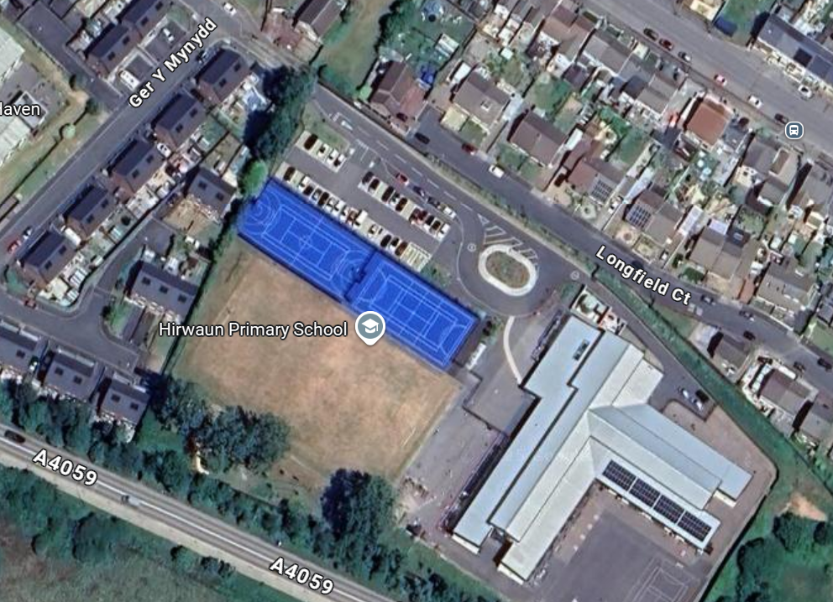
Main Gate and pedestrian gate
Car park
Bus drop off / pick up area

3. | Site Speed Limit
 | A significant factor in most traffic accidents is the speed at which the vehicle is being driven. This factor also significantly affects the severity of any injuries suffered by pedestrians. Therefore, the school operates a strict maximum speed limit of 5MPH throughout the school. Drivers are expected to adhere to the speed limit (as well as all other site rules) and drive appropriately, taking into account pedestrians as well as local weather conditions and other site traffic.
4. | Reversing
 | Reversing vehicles are a significant factor in many fatal accidents. Reversing on the school site is to be avoided as far as is practicable. In general, this is to be achieved by vehicles entering the site via main gates A, following the road around the roundabout within the site, and exiting the site via main gate Where reversing is unavoidable, for example when deliveries are made to the kitchens and there is no drive-through option beyond the kitchen delivery bay, drivers must use all reversing aids at their disposal, such as any alarms, cab-mounted CCTV, reversing assistants, etc., and check that the area is clear of pedestrians before carrying out a reversing manoeuvre. No reversing must be carried out during the morning drop off or afternoon collection periods. Any pedestrians in the vicinity of an area where reversing manoeuvres are being carried out must position themselves in a safe location and away from any crush zones.
5. | Pedestrians
 | Pedestrians must only access the school grounds from the designated entrances, which are the pedestrian gates B. Pedestrians need to recognise that these pedestrian gates are adjacent to vehicle access / egress gates that will be in use during peak times and must exercise caution. At no time are pupils to use the vehicle access / egress gates as there is a significant risk of collisions.
 | There are various footpaths around and in the school and all pedestrians must make sure that they use these safely and avoid spilling onto public highways and on-site vehicle routes. Pupils walking in groups must take this into account and allow other users to pass safely. Pedestrians must use the zebra crossings where provided. Dropped kerbs are provided throughout the site to provide suitable access and egress for wheelchair users.
 | During arrivals in the morning, entry into school buildings is only available via the reception, yard gate entrance. Additionally the side gate by the far classes is used when exiting the buildings at the end of the school day only.
6. | Staff
 | All members of staff, as responsible adults, must set a good example, particularly to pupils, but also to others, by complying with all site rules. This includes obeying the site speed limit, only parking in the designated staff car park (car park 1) and not parking haphazardly about the site, and using pedestrian routes after alighting their vehicles. Staff must remember that some pupils, particularly young ones, will have little appreciation of the risks associated with traffic movement and must take this into consideration when driving on or near the school.
 | All staff, irrespective of whether or not they are undertaking any formal supervisory or monitoring duties, must report any incidents of non-compliance with site rules they observe to the relevant person.
7. | Pupils
It is very important that pupils set a good example to others, particularly in the spirit of being a safe school. There are a number of rules that pupils should be aware of:

- Pupils and parents should use the pedestrian entry into the school grounds;
- Pupils being dropped off by parents must, wherever practicable, alight the vehicle on the kerbside only;
- Pupils must ensure that they stop, look and listen before crossing roads, especially when wearing hoodies or similar clothing that restricts vision to either side;
- When using the footpaths – walk, not run. This will avoid accidents and will make you more aware of what is happening around you;

Pupils must follow the instructions of staff and be aware of the following when accessing the bus drop off and pick up area:

- Staff will supervise pupils to embark and disembark the school transport
- The buses must be at a complete stop before embarking / disembarking;
- Pupils must appreciate that bus drivers may not be able to see pedestrians who are out of their direct line of sight and must act responsibly;
- Pupils must allow the staff / drivers to carry out their duties without distraction and behave well whilst on board. This ensures that vehicles can move off on time and the journey is comfortable for all.

8. | Car Parks
There is one car park within the school grounds. Car Park 1 is strictly for use by school staff only although there are two disabled parking bays in this car park that can be used by parents/ carers in receipt of a Blue Badge. The layby area is for Blue Badge holders only. Access to the site and car park is restricted during peak hours and no traffic movement apart from school transport is allowed.

Restrictions apply to the movement of vehicles during the morning drop off (08:50 – 09:10) and afternoon collection times (15:10– 15:30). No vehicles will be allowed to leave any of the car parks during these times.

Drivers should proceed slowly around the school and within the car parks at all times and within the designated 5MPH speed limit.

Staff are expected to act responsibly on the site when parking and accessing school buildings. If they are aware of unauthorised use of parking bays, this should be reported via the school receptionist or to the school’s Headteacher who will inform / remind the offending driver of the correct use of the site.

9. | Parents Dropping Off / Collecting Pupils
 | Vehicles driven by parents are not allowed on the school grounds during the morning drop off or afternoon pick up times. The school vehicle entrance gate is closed to non-home to school transport vehicles at 08:50 and re-opened at 09:10 in the mornings, and closed at 15:10 and re-opened at 15:30 in the afternoons, and supervised by a member of staff. During these periods, the member of staff will open the gate for home to school transport vehicles only. Drivers of any unauthorised vehicles will not be allowed on site and will be politely informed of this. Parents have been informed of this arrangement via Seesaw and newsletters. Any vehicles already on site will not be allowed to leave until after gate re-opening times.
10. | Visitors
 | Visitors must only park in the main car park. Doing so will allow unrestricted movement of other vehicles during the school day. If parking bays are unavailable, then visitors should park safely in the local community. All visitors must adhere to the 5MPH maximum speed limit on site, as well as all other site traffic rules.
 | Visitors are required to sign in at reception. On departure, visitors should sign out at reception and leave the building by the main entrance door. Disabled visitors may park in one of the disabled bays which are located in the visitors’ car park.
11. | Contractors / Deliveries / Waste & Recycling Collection / School Minibuses
Contractors and delivery drivers

Drivers of contractor and delivery vehicles must report to the reception desk in the main building to advise of the nature of their visit and to get clarification on where they can park and be advised of the site rules in relation to the area they are parking at the time, as appropriate to the nature of their visit. All drivers must adhere to the 5MPH maximum speed limit on site, as well as all other site traffic rules. Parking arrangements for contractors who are carrying out long term construction works on site must be agreed to prior to the commencement of the work.

Waste and Recycling Collection

All refuse and recycling collections are made prior to 7:30 am when only the caretaker is on site. The waste compound is located at the left and side of the school building. The refuse / recycling drivers must use reversing assistants during any reversing manoeuvre. All refuse and recycling vehicles must adhere to the 5MPH maximum speed limit on site, as well as all other site traffic rules.

12. | Home to School Transport
The SLT has designated a drop off and pick up point by the roundabout for the sole use of the Home to School transport buses throughout the day. No vehicles apart from the designated buses are allowed to stop or park in this area. The school has 1 x 52 seater and a 1x15 Seater buses arriving and departing from the school during the morning drop off and afternoon collection period.

Buses must be at a complete stop before allowing pupils to get on or off the bus. Engines should be switched off unless there is a valid safety reason to have the engine running. Only when pupils / pedestrians are clear of the vicinity of the area or are all on board should drivers exit the area, following the agreed departure arrangements and sequence with the designated school supervisor. All buses must adhere to the 5MPH maximum speed limit on site, as well as all other site traffic rules.

13. | Outside School
 | The school accepts that parking near the school is not easy. The residential streets outside the school are used by traffic into and out of the surrounding area. It is important that the school is a considerate neighbour to local residents. Parents / carers are asked not to park immediately outside the school, but to drop the children off further away, in a location where it is safe to do so, and allow them to walk the remaining distance. Pupils are reminded to walk on the pavements and enter via the dedicated pedestrian gate.
 | Drivers are asked to keep the road outside the entrance clear to allow vehicles to pass safely. Drivers are asked not to park indiscriminately, such as mounting pavements, double parking, stopping on any yellow lines, obstructing access points and parking near junctions, as this causes danger to pupils and other road users. Accidents can arise if views are obstructed or pedestrians have to negotiate between parked vehicles. In addition, the roads can become congested, which results in frustration to residents and delays to services and ongoing journeys.
14. | Supervision
 | There is a designated School Traffic Support Officer that supervises the entrance gate at drop off and pick up times. They must position themselves in a safe location when undertaking their role. High visibility waistcoats or jackets must be worn when carrying out these duties.
15. | Monitoring of Compliance Against this Plan
Key to the ongoing monitoring of the plan is the role of SLT and other staff. All staff have a responsibility to make sure that they are acting in such a way as not to compromise the health and safety of themselves or others. In addition to the supervision arrangements in place. The Headteacher will liaise with the Traffic Officer regularly to ensure that plan is effective and address any issues as they arise.

Traffic and driving issues arising from the behaviour of parents, contractors, delivery drivers, cleaning and catering staff will be dealt with by the Heateacher.

The Head of Year will be responsible for addressing the conduct of pupils where it is not consistent with the requirements of this TMP.

Home to school transport issues will be reported to the Integrated Transport Unit. Issues involving contractors’ employees, drivers of delivery vehicles or similar will be reported to the relevant employer. All staffing issues will be dealt with by the Head Teacher. The HT will ensure that both the school traffic management risk assessment and this TMP is updated to reflect any amendments to the actual traffic management arrangements at the school.

16. | Reporting of On-site Traffic Incidents / Accident
 | Incidents and accidents must be reported initially to the Headteacher, who will then inform the Council’s Corporate Health and Safety Team using the Incident / Accident Investigation and Injury Record Form HS5(A).

Appendix 1 – Morning Drop Off Arrangements
Morning Drop Off Arrangements

Morning

During the morning drop off the school has 1 x 52 seater bus and 1x15 minibus arriving / leaving between 08:50 and 09:10. Buses arrive through the entrance, and park in the designated area by the roundabout. When the buses have stopped the staff meet the bus and the pupils alight the bus under the supervision of the staff members. Pupils alight the bus directly onto the footpath and make their way to their registration class. Once all pupils have alighted, the buses will be allowed to drive off site.

General Supervisors Role

Staff should be proactive in supervising. General duties include:

- challenging unauthorised or inappropriate parking which creates a hazard or congestion;
- steering pedestrians away from hazard areas;
- supervising bus collections and determining, for example, when it is safe for buses to move from bus bays;
- challenging and reporting incidents of excessive speed;
- challenging and reporting drivers and pedestrians ignoring signs / instructions or otherwise contravening site traffic rules, using mobile phones when driving and other inappropriate behaviour.

Appendix 2 – Afternoon Pick Up Arrangements

Afternoon Pick Up Arrangements

During the afternoon collection period the school has 1 x 52 seater bus and a 1x15 seater minibus arriving / leaving between 15:00 and 15:20.
Buses arrive through the entrance, and park in the designated area by the roundabout. The staff meet the bus and the pupils board the bus under the supervision of the staff members directly from the footpath. Once all pupils have they seatbelts on under the supervision of the escorts, the buses will be allowed to drive off site.

General Supervisors Role

Staff should be proactive in supervising. General duties include:

- challenging unauthorised or inappropriate parking which creates a hazard or congestion;
- steering pedestrians away from hazard areas;
- supervising bus collections and determining for example ,when it is safe for buses to move from bus bays;
- challenging and reporting incidents of excessive speed;
- challenging and reporting drivers and pedestrians ignoring signs / instructions or otherwise contravening site traffic rules, using mobile phones when driving and other inappropriate behaviour.

Signed: | B Hill | M Morgan
Designation: | Headteacher | Chair of Governors
Date completed: | June 2025
Date uploaded onto RAMIS: | September 2025
Planned Review date: | June 2025

